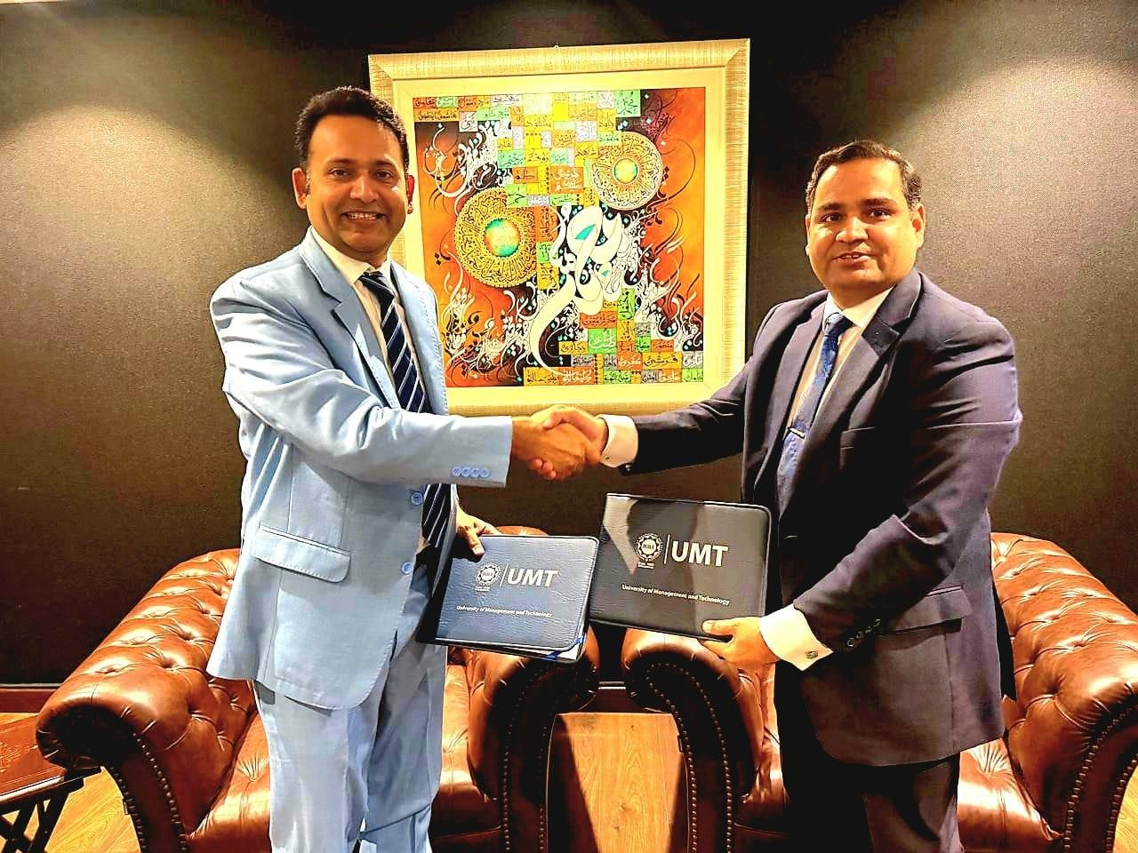
MoU Signing with UMT, Lahore

